Course outline for Cyber law & ethics:

Ethics:

Sir ei website thekeporte bolchen.Class e basically temonkichu likhanu hoy nai..Different topic niyea discusion hoiche.website link:

http://www.iep.utm.edu/ethics/

Ethics tt question:

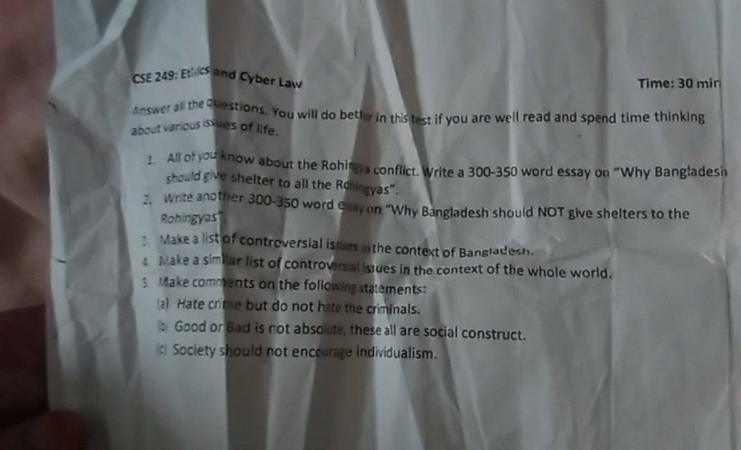
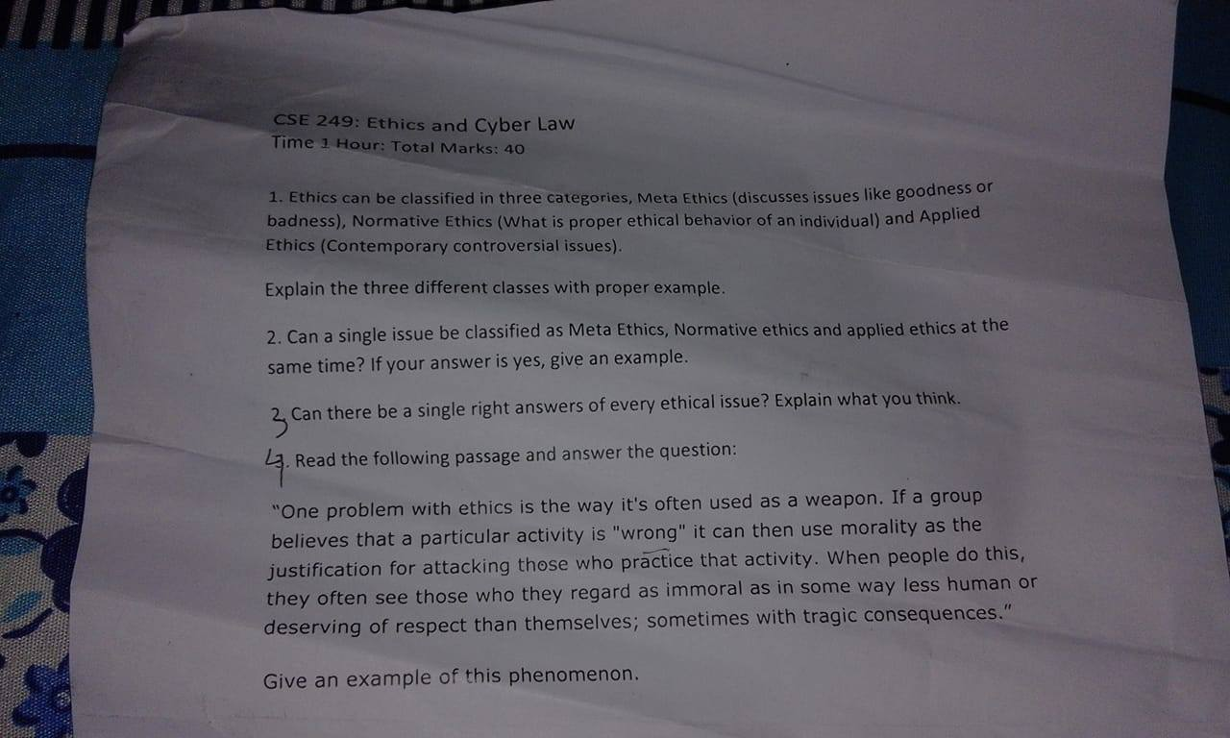

Cyber law:

13 ta sheet jononi te dewa ache..Sheet thekei asbe..

TT question:
